Copyright Laws, Google and Unsplash

Last week’s class was very interesting as I did not know a lot of the ins and outs of what was free to use and not use even for images, even simple blog posts or power point projects. I assumed if it showed up on Google (as far as images go) that they were free to use with credit to the Google page, as long as it was for school or personal purposes. The Unsplash site that we looked at is a really cool resource that I was unaware of. It will be a great resource for students as well, for image use in their presentations or projects without the stress of wondering where the images came from and how they can credit them or if they’re even able to use them.

As an art major, I struggled with this a lot in my undergrad. We often had to make such presentations or talk about artists, and even incorporate past artists work in our own in some way, and there is a lot of grey area around what can and cannot be
used as well as all the avenues of art appropriation. These issues will probably be less necessary to address in a high school art classroom but the sites we looked at in class will at least facilitate students’ processes as they begin to maneuver through copyright issues when creating their own work.

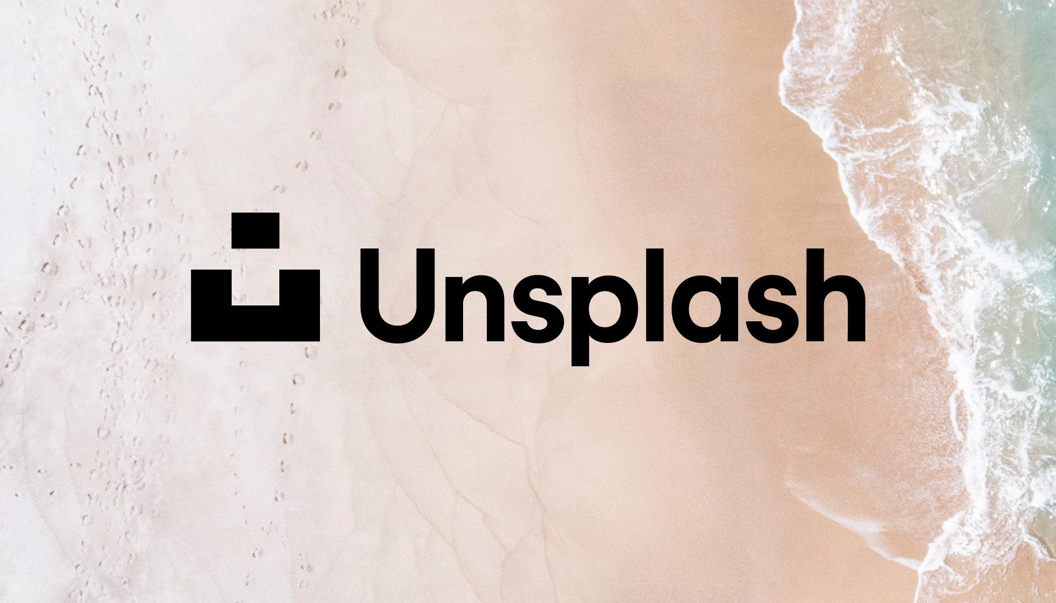
This class made me realize that the use of filters is also a great way of figuring out which sites and images are usable and to what extent they need to be credited, going beyond simply including the broad link where they first appeared. The free inquiry project will require lots of research and photos around my chosen topic and I will now be more mindful of where the information is from and how I will be using it myself.

